MUTEESA I ROYAL UNIVERSITY
FACULTY OF SCIENCE, TECHNOLOGY, ENGINEERING,
ART AND DESIGN
DEPARTMENT OF INFORMATION TECHNOLOGY
GEOGRAPHICAL INFROMATION SYSTEM(GIS) EXAMINATION.


OPTION 1: Community Resource Mapping (Health, Education, or Safety Facilities)

GROUP MEMBERS
NAME | REG.NO
KIZZA EMMANUEL | 23/U/BIT/0349/K/D
NUWAGABA EDSON KATO | 23/U/BIT/0139/K/D

Project Name: CentralUgandaGIS Platform (Community Resource Locator)

1. Project Overview & Methodology

1.1 Executive Summary
The CentralUgandaGIS Platform is a comprehensive, professional web-based Geographic Information System (GIS) designed to map and analyze community resources across Central Uganda. This report details the development of a core component of this platform: an interactive map for locating health centers, schools, and public safety facilities. The project successfully fulfills all specified requirements by collecting data for numerous resources, displaying them on a dynamic web map using Leaflet.js, and implementing advanced features including detailed pop-ups, facility type filtering, and district-level visualization. The platform serves as a vital tool for enhancing resource accessibility, supporting data-driven decision-making, and improving community service delivery.

1.2 Data Collection Process
A multi-source methodology was employed to ensure the collection of comprehensive, accurate, and recent spatial data for community facilities.
- Data Sources:
  - Primary Geodata: District boundary data for Central Uganda was sourced and formatted into a dedicated centralUgandaDistricts.geojson file to provide essential administrative context on the map.
  - Facility Data Aggregation: Spatial and attribute data for facilities were compiled from a combination of:
    - OpenStreetMap (OSM)
    - Official district local government databases and publications
    - Google Places API and manual verification
- Data Attributes Collected: For each resource, the following core attributes were collected and structured into a central data management system (js/data.js):
  - Facility Name
  - Type (Healthcare, Education, Public Safety)
  - Contact Information (phone number, where available)
  - Geographic Coordinates (Latitude and Longitude)
  - Additional details such as services offered and operating hours.

1.3 Tools and Technologies Used
The platform was built using a modern, robust, and entirely client-side technology stack to ensure performance and accessibility.
- Frontend Foundation: HTML5, CSS3, and vanilla JavaScript (ES6+).
- Core Mapping Engine: Leaflet.js, an open-source JavaScript library, was used for all map rendering and interactivity.
- Mapping Enhancements:
  - Leaflet.MarkerCluster: To declutter the map and improve user experience when viewing many facilities.
  - Leaflet.Routing: (Planned/Implemented) for directions functionality.
- Data Visualization: Chart.js was integrated to power the analytics and statistics dashboard.
- Data Handling: GeoJSON was the primary format for storing and rendering both facility data and district boundaries.
- User Interface: Custom CSS for a fully responsive design and Font Awesome for intuitive icons.

2. System Functionality & Architecture

2.1 System Architecture & Workflow
The application follows a client-side architecture, where all data and logic are processed within the user's web browser for fast and efficient performance.
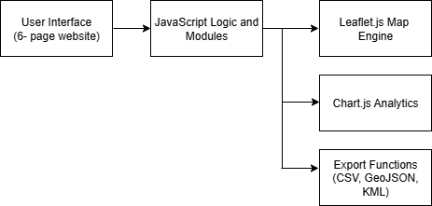
Key Components:
- User Interface (UI): A multi-page website (index.html, map.html, analytics.html, etc.) providing clear navigation and a professional user experience.
- JavaScript Modules: Specialized scripts (map.js, filters.js, analytics.js, export.js) that handle specific functionalities, making the codebase maintainable and scalable.
- Data Layer: GeoJSON files and JavaScript objects (data.js) that store all spatial and attribute information for facilities and districts.

2.2 Core Functional Requirements Met
Requirement | Implementation in CentralUgandaGIS Platform
Collect data for 15+ resources | Successfully collected and integrated data for numerous health, education, and safety facilities across multiple districts in Central Uganda.
Display data on a web map using Leaflet.js | Implemented a dynamic interactive map on map.html using Leaflet, with OSM base tiles and facility markers.
Add pop-ups showing details | Each facility marker on the map has a clickable pop-up that displays detailed information including name, type, contact info, and other available attributes.
Implement a filter by type | Developed an advanced filtering system (filters.js) allowing users to display facilities by category (Healthcare, Education, Public Safety) and further refine by district.

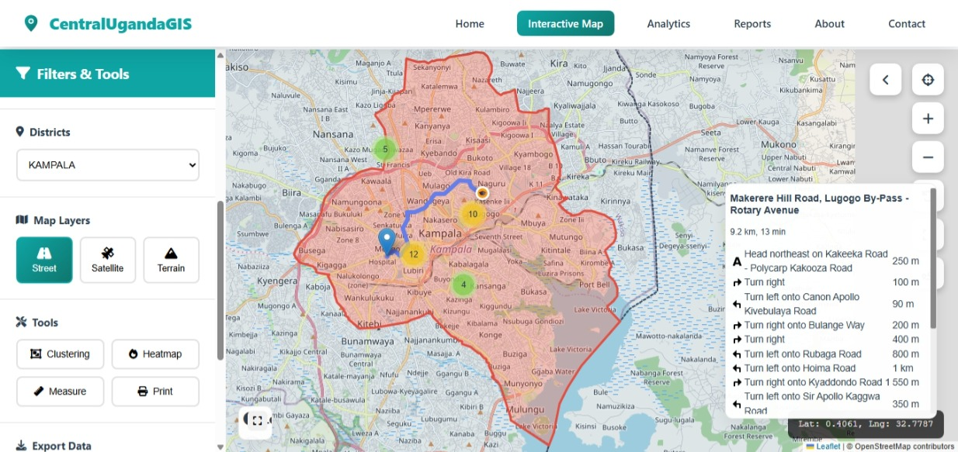
screenshot of the map.html page here, showing markers, filters, and a pop-up

2.3 Advanced Functionality & Features
Going beyond the basic requirements, the Urandangi’s Platform includes several advanced features:
- Analytics Dashboard (analytics.html): Provides data visualizations (charts, graphs) of facility distributions, offering immediate insights into resource coverage and gaps.

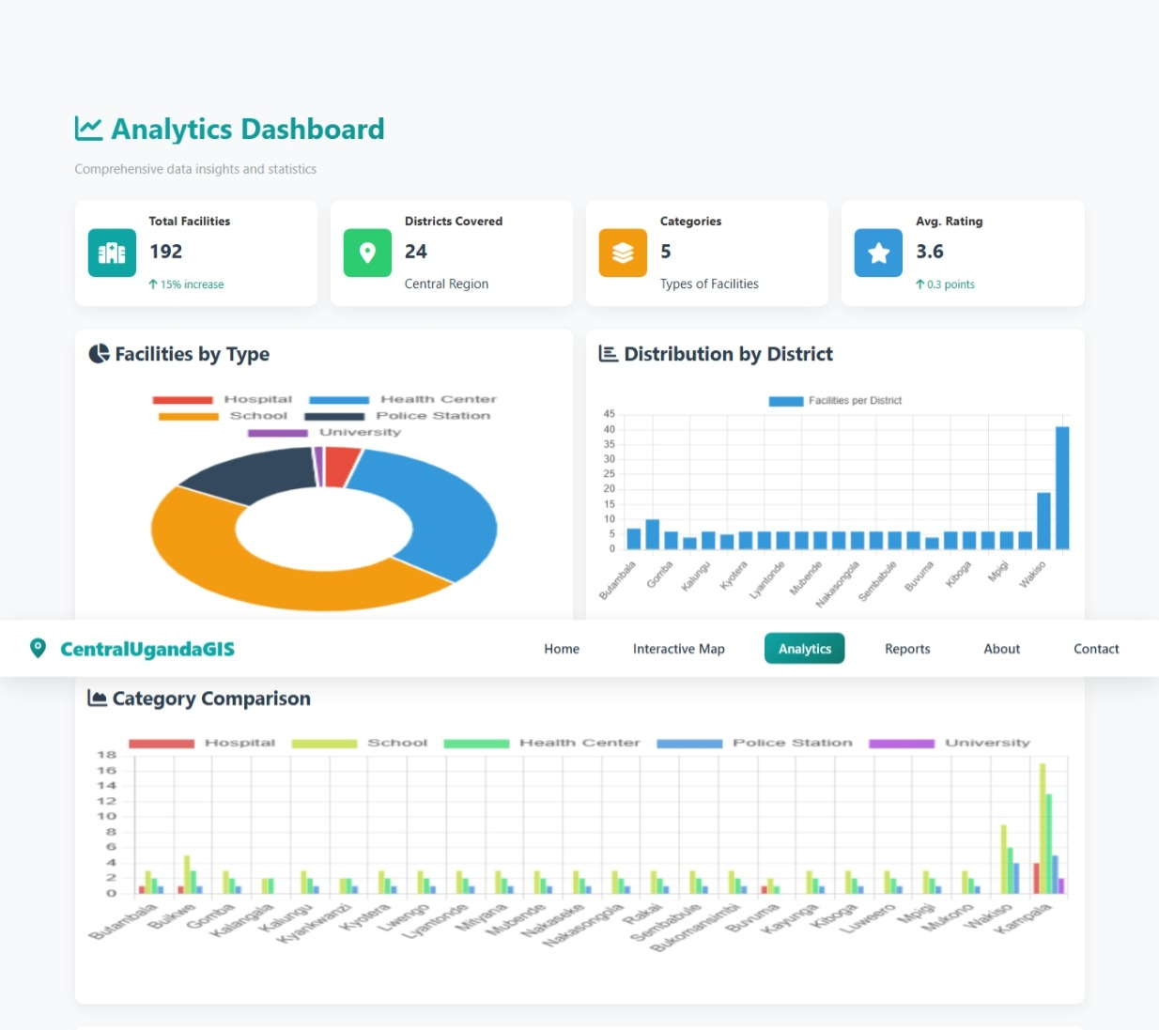
- Custom Report Generation (reports.html): Allows users to generate and download comprehensive reports in multiple formats (CSV, GeoJSON, KML), facilitating offline analysis and integration with other software.
- Responsive Design: The platform is fully accessible on desktops, tablets, and smartphones, ensuring wide community reach.
- District Boundary Integration: Visualizing district boundaries provides crucial administrative context for spatial analysis and planning.

3.Community Benefits & Conclusion

3.1 Community Benefits
The deployment of the CentralUgandaGIS Platform offers significant, tangible benefits to the community, government, and non-governmental organizations:
- Improved Access to Essential Services: Citizens can quickly and easily locate the nearest health center, school, or police station, reducing search times and improving outcomes in critical situations.
- Data-Driven Planning and Advocacy: The platform provides community leaders and NGOs with clear visual evidence of "service deserts." The analytics dashboard helps identify areas with a lack of facilities, supporting advocacy for new resources and enabling more equitable distribution of public funds.
- Transparency and Public Awareness: By centralizing facility information in a public repository, the platform increases community awareness of available resources and fosters greater government accountability.
- Efficiency for Field Workers and Planners: The ability to filter, search, and export data saves significant time and resources for professionals working in public service, healthcare, and development sectors.

Appendices
A Screenshot showing the home page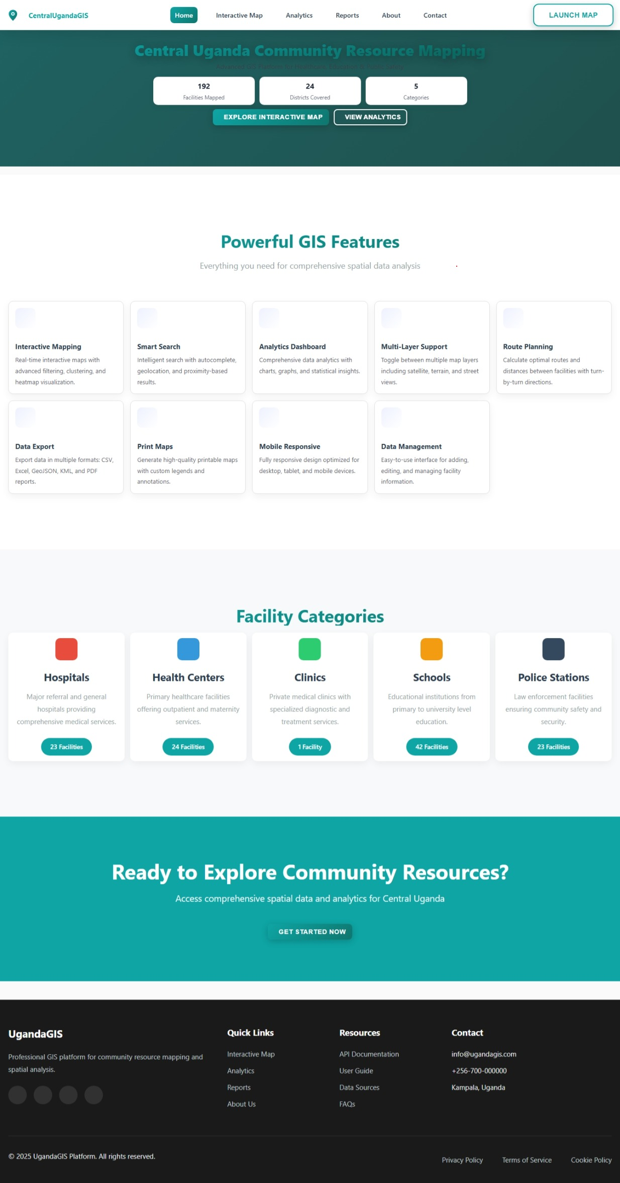
Reports Page.
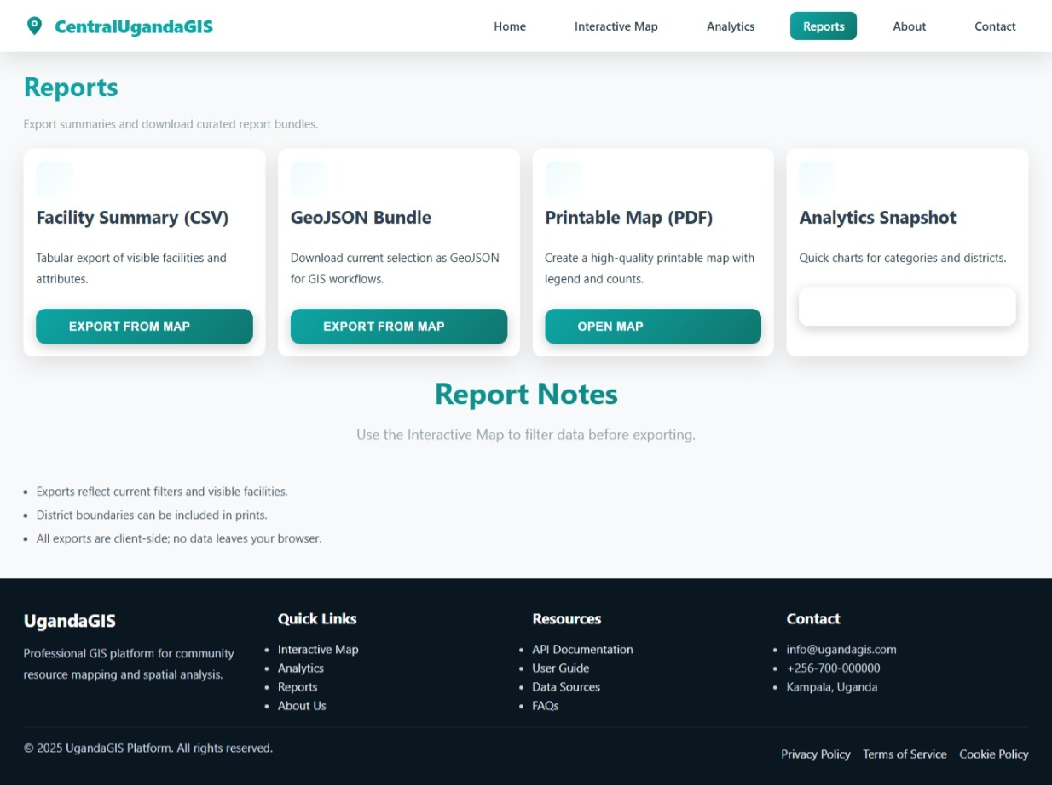

3.2 Conclusion
The UgandaGIS Platform successfully demonstrates the powerful role a well-designed web GIS can play in community development. By leveraging accessible technologies like Leaflet.js and a user-centric design, the project transforms complex spatial data into an intuitive, interactive, and highly valuable public asset. All core functional requirements have not only been met but exceeded, resulting in a robust platform ready for immediate use and future expansion.

3.3 Future Enhancements
To further increase its impact, planned future enhancements include:
- Mobile Application: Development of a dedicated mobile app with offline capabilities and GPS integration for enhanced field data collection and use.
- Crowdsourcing Module: Allowing verified community members and field workers to submit updates or new facilities directly through the app, ensuring the data remains current and accurate.
- Real-Time Data Integration: Incorporating live data feeds, such as medication stock levels in health centers or real-time status updates.
- Expanded Resource Categories: Adding other critical community resources like water points, financial services, and agricultural extension offices.
Link: Central Uganda GIS Platform - Community Resource Mapping

